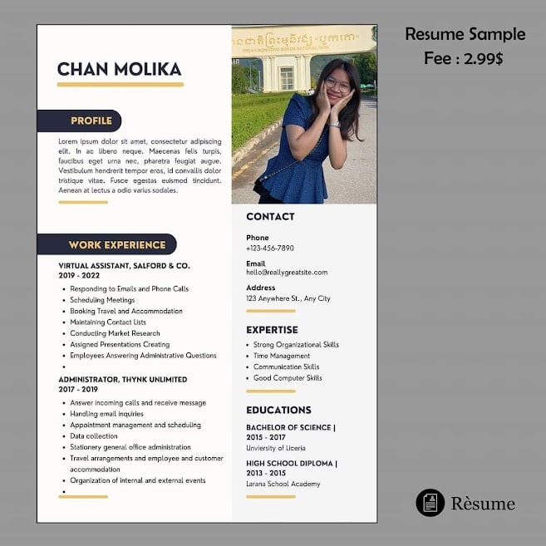



**EDUCATION**

**BACHELOR OF SCIENCE**

**2015-2017**

**HIGH SCHOOL DIPLOMA**

**2013-2015**

Larana school academy

**EXPERTISE**

* Strong Organization Skills
* Time Management
* Communication Skills
* Good Computer Skills

**ADMINISTRATOR,THYNK UNLIMITED**

**2017-2019**

* Answering Incoming calls and receive message
* Handing email inquiries
* Appointment management and schetduling
* Date collection
* Stationery general office administration
* Travel arangement and employee and customer

accomodation

* Organization of internal and external events

**Contast**

**Phone**

+123-456-7890

## Email

[hello@reallygreatsite.com](mailto:hello@reallygreatsite.com)

## Address

Street 371, sorla, Phnom Penh

MAO PHEAKTRA

**VIRTUAL ASSISTANT, SALFORD & CO.**

**2019-2020**

* Responding to Email And Phone Calls.
* Schedulign Meeting
* Booking Travel and Accomodation
* Maintaining Contact Lists
* Conducting Market Research
* Assigned Presenting Creating
* Amployees Answering Administrative Questions

WORK EXPERIENCE

PROFILE

Lorem ipsum dolor sit amet, consectetur adipiscing elit, sed do eiusmod tempor incididunt ut labore et dolore magna aliqua. Ut enim ad minim veniam, quis nostrud exercitation ullamco laboris nisi ut aliquip ex ea commodo consequat. Duis aute irure dolor in reprehenderit in voluptate velit esse cillum dolore eu fugiat nulla pariatur. Excepteur sint occaecat cupidatat non proident, sunt in culpa qui officia deserunt mollit anim id est laborum.